Updated 1-27-2022

How to Get a Copy of Your Form

If you need a copy of a form filed with TaxMe, there are two ways to obtain:

Method 1: Email Request
Send an email to info@tax-me.com Please include:
- The name of the Company;
- The form you are requesting; and
- The period you are requesting.

Method 2: Facial Recognition Utility
Retrieve your form yourself using TaxMe’s Facial Recognition Utility.

To use this method, you FIRST need to be registered, which is a one-time process. If you are already registered, skip to step 5.

Click this link to begin: https://tax-me.com/f_access.php

Method 2: Registration Steps
- Select the form you filed and want to obtain. (If you filed more than one form, you can select any of them.)
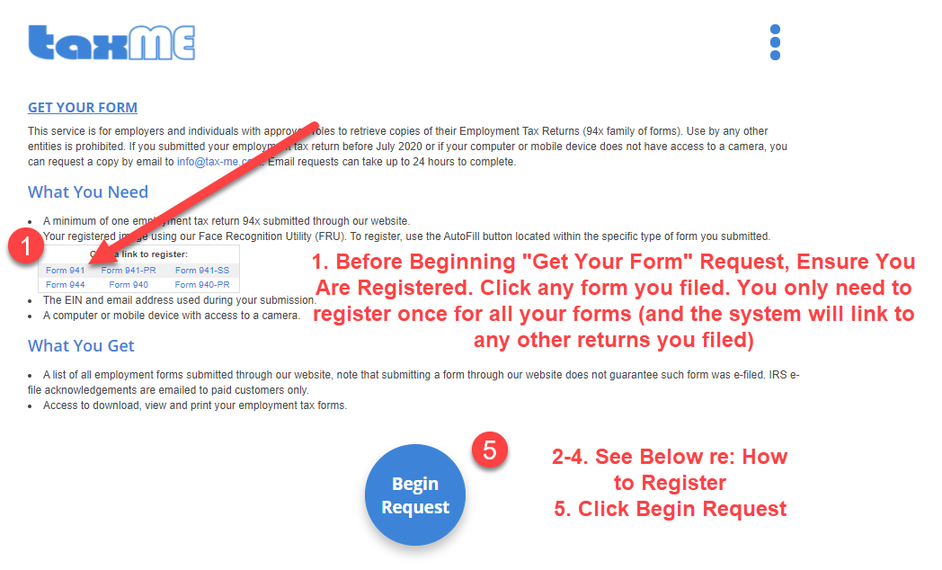
- On the page that pops up, click the blue “AutoFill” Button near the top;
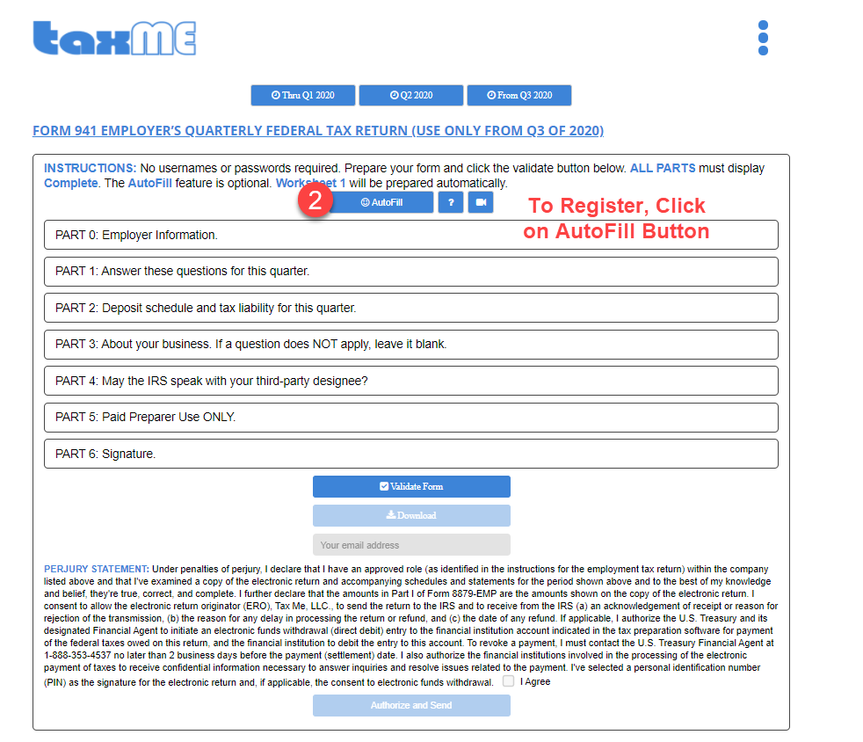

- Enter the credentials used when the return originally was filed: Company EIN and Email (For security, these will need to match those used in the original submission); and check the two boxes to consent.
- Select Register and you will see “Image uploaded safely” if successful.

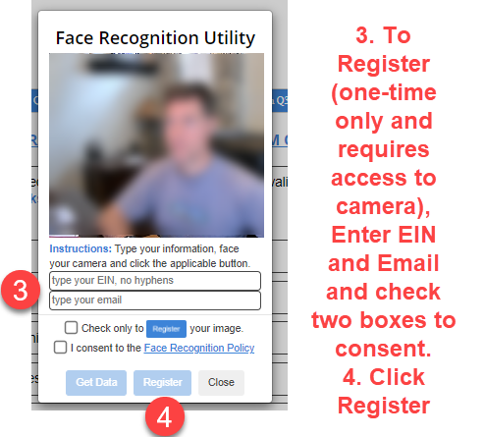

Method 2: Steps AFTER Registration

- Once registered: Click the blue “Begin Request” Button. Here’s the link again:
https://tax-me.com/f_access.php

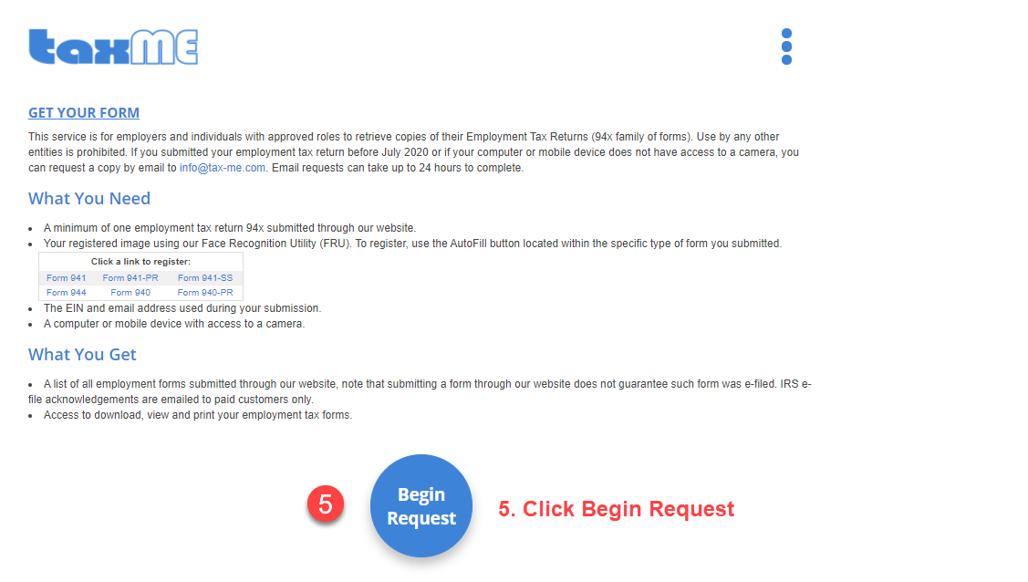

- Enter the credentials used when originally filed: Company EIN and Email (For security, these will need to match those used in the original submission), and click consent.
- A screen will pop up showing all your filings. Select the one you want to download and save it.
- Click “Click here when finished” to exit

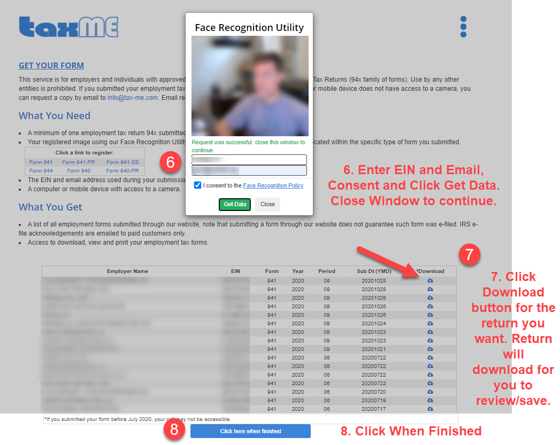
If you don’t get notification to download, then your PC may be configured to drop all downloads into the downloads folder in your PC. Please check there.

In addition, your computer must have access to a camera. We support the latest versions of Chrome, FireFox and Edge browsers. Apple devices are not supported

Possible Third Method
Your Form should have been downloaded at the time you submitted it. Thus, if you haven’t checked, it’s possible there may be a copy saved in your computers’ download folder.

